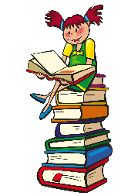

Mrs. Evelyn’s Supply List

Welcome to a New Homeschooling year!!

Supply List
- 1- Labeled Water Bottle
- 1-24 Ct. Crayons
- 1- Scissors
- 2- Glue Sticks
- 1- 1 Subject Spiral Notebook Wide Ruler
- 1- 12 pack or more of #2 Ticonderoga Pencils
- 1- 12” inch/cm ruler
- 1- pack of Index Cards.
- 1- pack of pink erasers
- 1- box of color pencils
- 1- 6 roll paper towel.
- 5- Reams of copy paper.
- 2- Lysol Disinfectant Spray
- 1- pack of Toilet paper

- 1- Headphones, Ziploc and labeled with child’s name on it
- Students will need a laptop

Teacher Wish List

- Baby wipes for your child after recess
- Large bag of Dum Dums Lollipops

